
Sukkur Institute of Business Administration University
Department of Computer Science
BS – I (CS/SE) Fall 2025
Programming Fundamentals
Assignment 01 # 11 To become familiar with the String Type Variables

String data type
A string is called as a collection/sequence of characters such as “Hi” or “I am a student”. Strings are enclosed within double quotes “”. In order to use the string data type, the C++ string header
<string> must be included at the top of the program. Also, you’ll need to include using namespace std; to make the short name string visible instead of requiring the cumbersome std::string.
There are two types of strings commonly used in C++:
- C-strings (C-style Strings)
- Strings that are objects of string class (The Standard C++ Library string class)

C-strings
In C programming, the collection of characters is stored in the form of arrays. This is also supported in C++ programming. Hence it's called C-strings.
C-strings are arrays of type char terminated with null character, that is, \0 (ASCII value of null
character is 0). For example,
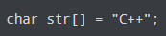
In the above code snippet, str is a string and it holds 4 characters. Although the literal "C++" has 3 character, the null character \0 is added to the end of the string automatically to indicate the end of string.
Likewise:
char s[] = {'C', '+', '+', '\0'};
char s[4] = {'C', '+', '+', '\0'};
char s[4] = "C++";

char s[] = "C++";

C++ string
Most of the time we will be using C++ string class (provided by the C++ library) because it is easier to use than C-strings.
Just like creating variables of other data types, to create a string we first declare it, then we can store a value in it, like shown below:
We can combine these two statements into one line:
or
string testString("This is a string.");
Often, we use strings as output in the cout statement. So, if we write:
It will be the same as writing:

Getting input into a string variable
We cannot use the standard cin statement for getting input into a string variable. Consider the following code:
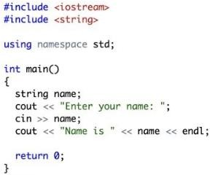

Output:
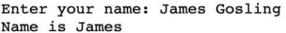

Here, only the first word “James” is assigned to the variable. The text after the space after the first word is ignored. To get the entire line of text, we should use a built-in function getline() as shown below:

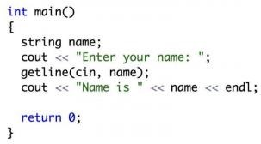

Output 1:
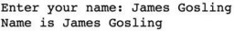

Output 2:
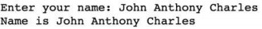

Strings – Basic operations (built-in functions of string class)

Counting the number of characters in a string:
The length( ) method returns the number of characters in a string, including spaces and punctuation. Like many of the string operations, length is a member (built-in) function, and we invoke member functions using dot notation. The string that is the receiver is to the left of the dot, the member function we are invoking is to the right, (e.g. str.length( )). In such an expression, we are requesting the length from the string variable str.
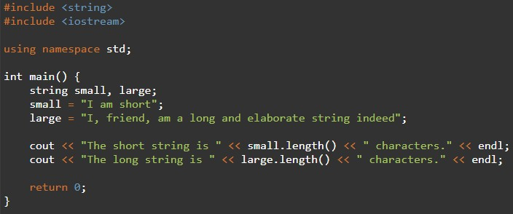

Output:

Accessing individual characters
Using square brackets [ ], you can access individual characters within a string as if it’s a char array. Positions within a string type variable str are numbered from 0 through str.length( ) - 1 (like array indices).
You can read and write to characters within a string using [ ]. For example, see the code sample below:
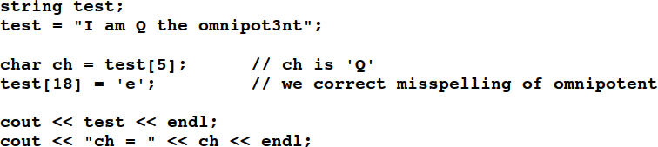
Output:
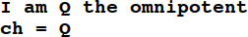

Be careful not to access positions outside the bounds of the string. The square bracket operator [ ] is not range-checked and thus reading from or writing to an out-of-bounds index tends to produce difficult-to-track-down errors.
There is an alternate member function at (int index) that retrieves the character at a position with the benefit of built-in range-checking, but it’s used much less often.

Passing, returning, assigning strings
C++ strings are designed to behave like ordinary primitive data types with regard to assignment. Assigning one string to another makes a deep copy of the character sequence. For example,
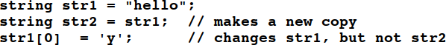
Passing and returning strings from functions clones/copies the string (or is passed by value). If you change a string parameter within a function, changes are not seen in the calling function unless you have specifically passed the string by reference (e.g. using the &).

Comparing two strings
You can compare two strings for equality using the == and != operators. An example code is shown below:
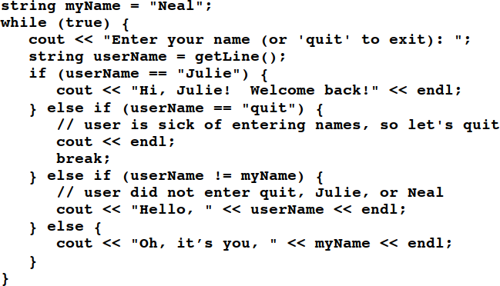
Output:
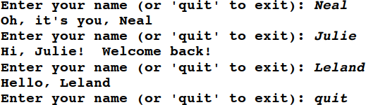

You can also use other comparison operators like <, <=, >, and >= to compare strings. These operators compare strings lexicographically, character by character and are case-sensitive. The following comparisons all evaluate to true (the result after comparison is true):

"A" < "B", "App" < "Apple", "help" > "hello", "Apple" < "apple"
The last one might be a bit confusing, but the ASCII value for 'A' is 65, and comes before 'a', whose ASCII value is 97. So "Apple" comes before "apple" (or, for that matter, any other word that starts with a lower-case letter).

Appending to a string
Suppose you have two strings, s1 and s2 and you want to create a new string of their concatenation. Conveniently, you can just write s1 + s2, and you’ll get the result you’d expect.

Similarly, if you want to append to the end of string, you can use the += operator. You can append either another string or a single character to the end of a string. For example,
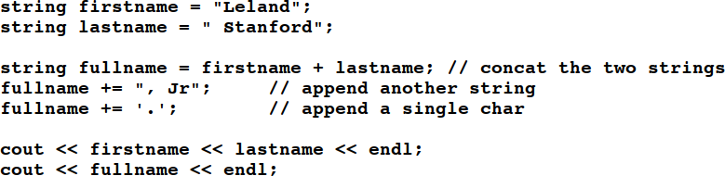

Output:
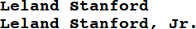

Searching within a string
The string member function find( ) is used to search within a string for a particular string or character. A sample usage such as str.find(key) searches the key (the string or character value passed as argument) from the string str. The parameter key can either be a string or a character. The return value is either the starting position where the key was found or the constant string::npos that indicates the key was not found.

Example:
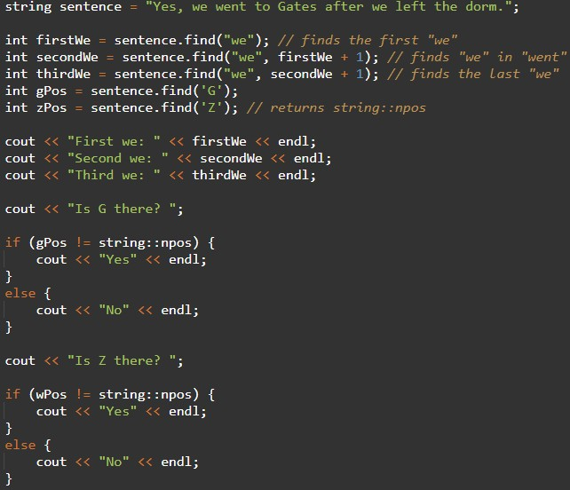

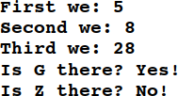
Output:

Extracting substrings
Sometimes you would like to create new strings by extracting portions of a larger one. The
substr( ) member function creates substrings from pieces of the receiver string.
You specify the starting position and the number of characters (to extract from the original/receiver string). For example, str.substr(start, length) returns a new string consisting of the characters from str starting at the position start and continuing for length characters.
Invoking this member function does not change the receiver string, as it makes a new string with a copy of the characters specified. See the example code below:
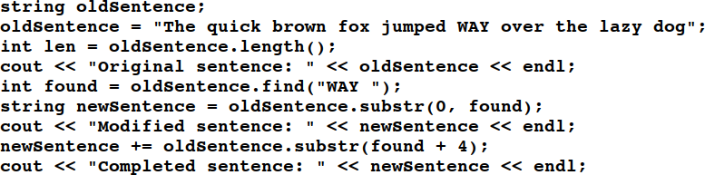

Output:

For more concepts and definition visit the links mentioned below:
https://www.geeksforgeeks.org/strings-in-cpp/
https://www.tutorialspoint.com/cplusplus/cpp_strings.htm

Explore the link given below for more exciting exercises.
https://www.w3resource.com/cpp-exercises/string/index.php

Practice Task No. 1: Student Grading

You are tasked with creating a program to calculate and display the final grades for a class of students. You need to take the following inputs for each student:
- Student's name
- Three test scores
- Attendance percentage
You should calculate the final grade using the following weights:
- Test scores: 70%
- Attendance: 30%

Then, display the student's name, test scores, attendance, and final grade. Use setw for proper formatting.
#include <iostream>
#include <iomanip>
#include <string>

using namespace std;

const int MAX_STUDENTS = 100;
int main() {
int numStudents;
cout << "Enter the number of students: ";
cin >> numStudents;

if (numStudents <= 0 || numStudents > MAX_STUDENTS) {
cout << "Invalid number of students. Please enter a positive integer less than or equal to " << MAX_STUDENTS << "." << endl;
return 1; // Exit with an error code
}

// Arrays to store student information
string names[MAX_STUDENTS];
double test1[MAX_STUDENTS], test2[MAX_STUDENTS], test3[MAX_STUDENTS], attendance[MAX_STUDENTS];
double finalGrades[MAX_STUDENTS];

// Clear the input buffer
cin.ignore();
// Input student information and calculate final grades
for (int i = 0; i < numStudents; ++i) {
cout << "Enter the student's name: ";
getline(cin, names[i]);

cout << "Enter test score 1: ";
cin >> test1[i];

cout << "Enter test score 2: ";
cin >> test2[i];

cout << "Enter test score 3: ";
cin >> test3[i];

cout << "Enter attendance percentage: ";
cin >> attendance[i];

// Calculate the final grade with the specified weights
finalGrades[i] = 0.7 * ((test1[i] + test2[i] + test3[i]) / 3.0) + 0.3 * attendance[i];

// Clear the input buffer
cin.ignore();
}
// Display student information and final grades with proper formatting
cout << "\nStudent Grades:\n";
for (int i = 0; i < numStudents; ++i) {
cout << "Student Name: " << setw(20) << left << names[i] << endl;
cout << "Test Scores: " << setw(5) << right << test1[i] << setw(5) << right << test2[i] << setw(5) << right << test3[i] << endl;
cout << "Attendance: " << setw(6) << right << attendance[i] << "%" << endl;
cout << "Final Grade: " << setw(6) << right << fixed << setprecision(2) << finalGrades[i] << "\n" << endl;
}
return 0;
}
Practice Task2:
Write a program that prompts the user to input 10 names (strings) and stores them in an array. Then, ask the user to enter a name to search for in the array. Check if the name exists in the array and display an appropriate message.

#include <iostream>
#include <string>
using namespace std;
int main() {
string names[10]; // Initialize an array to store names
// Input 10 names from the user
for (int i = 0; i < 10; ++i) {
cout << "Enter name " << (i + 1) << ": ";
cin >> names[i];
}
// Ask the user for a name to search
string searchName;
cout << "Enter a name to search for: ";
cin >> searchName;
// Check if the name exists in the array
bool found = false;
for (int i = 0; i < 10; ++i) {
if (names[i] == searchName) {
found = true;
break;
}
}
// Display the result
if (found) {
cout << searchName << " was found in the list." << endl;
} else {
cout << searchName << " was not found in the list." << endl;
}
return 0;
}

Practice Task3:
Write a program to demonstrate the use of class cstring functions, and also convert the string into lower or upper case.

#include <iostream>
#include <cstring>

using namespace std;

int main ()
{

char str1[20] = "Hello world! ";
char str2[20] = "How are you";
char str3[50];
int len ;

// copy str1 into str3
strcpy( str3, str1);
cout << "strcpy( str3, str1) : " << str3 << endl;

// concatenates str1 and str2
strcat( str1, str2);
cout << "strcat( str1, str2): " << str1 << endl;

// total lenghth of str1 after concatenation
len = strlen(str1);
cout << "strlen(str1) : " << len << endl;

// String case conversion using cctype functions
string mixedCase = str1;
for (int i = 0; i < mixedCase.length(); ++i) {
mixedCase[i] = toupper(mixedCase[i]); // Convert to uppercase
}
cout << "Uppercase string: " << mixedCase << endl;

for (int i = 0; i < mixedCase.length(); ++i) {
mixedCase[i] = tolower(mixedCase[i]); // Convert to lowercase
}
cout << "Lowercase string: " << mixedCase << endl;

return 0;
}

Practice Task4:
Write a program to demonstrate the use of class string class functions

#include <iostream>
#include <string>
using namespace std;
int main() {
// Declare and initialize strings
string str1 = "Hello, ";
string str2 = "world!";
string str3;
// Concatenation using + operator
str3 = str1 + str2;
cout << "Concatenation (+ operator): " << str3 << endl;

// Length of a string using length() or size() function
cout << "Length of str3: " << str3.length() << " or " << str3.size() << " characters" << endl;

// Accessing characters in a string using []
cout << "Character at index 7: " << str3[7] << endl;

// Substring using substr() function
string substring = str3.substr(0, 5);
cout << "Substring (0-4): " << substring << endl;

// Find a substring using find() function
int found = str3.find("world");
if (found != string::npos) {
cout << "Found 'world' at position " << found << endl;
} else {
cout << "Substring not found." << endl;
}

// Replace a substring using replace() function
str3.replace(7, 5, "there");
cout << "After replacement: " << str3 << endl;

// Check if a string is empty using empty() function
if (str3.empty()) {
cout << "str3 is empty." << endl;
} else {
cout << "str3 is not empty." << endl;
}

// Compare strings using compare() function
string str4 = "Hello, there!";
int comparison = str3.compare(str4);
if (comparison == 0) {
cout << "str3 and str4 are equal." << endl;
} else if (comparison < 0) {
cout << "str3 is less than str4." << endl;
} else {
cout << "str3 is greater than str4." << endl;
}
return 0;}

Practice Task5:
Ask the user to input a sentence as a string. Then, count and display the frequency of each vowel (a, e, i, o, u) in the sentence.

#include <iostream>
#include <string>

using namespace std;

int main() {
cout << "Enter a sentence: ";
string sentence;
getline(cin, sentence);

int vowelCount[5] = {0}; // Initialize an array to store the counts of 'a', 'e', 'i', 'o', 'u'.

for (int i = 0; i <= sentence.length(); i++ ) {
char lowercaseC = tolower(sentence[i]); // Convert the character to lowercase.

if (lowercaseC == 'a') {
vowelCount[0]++;
} else if (lowercaseC == 'e') {
vowelCount[1]++;
} else if (lowercaseC == 'i') {
vowelCount[2]++;
} else if (lowercaseC == 'o') {
vowelCount[3]++;
} else if (lowercaseC == 'u') {
vowelCount[4]++;
}
}

cout << "Vowel frequencies in the sentence:" << endl;
cout << "a: " << vowelCount[0] << " times" << endl;
cout << "e: " << vowelCount[1] << " times" << endl;
cout << "i: " << vowelCount[2] << " times" << endl;
cout << "o: " << vowelCount[3] << " times" << endl;
cout << "u: " << vowelCount[4] << " times" << endl;

return 0;
}

Exercises
- Write a C++ program where you should ask the use to input a date in the format DD/MM/YYYY (like 26/01/2022) where day, month, and year are separated by a slash. Then, print day or date, month, and year on a separate line (like 26 should be printed on one line, 01 on the second line, and 2022 on the third line).

- Create a user-defined function that should take one string parameter and it should return an integer value: the count or number of words in that string. Then, call it in the main ( ), where you should ask the user to enter any string value (can be an entire line), pass that value to the function being called, and display the returned value.

- Write a C++ program that should ask the user to input a phone number where the network and number are separated by a dash “-” like 0300-1234567.
Then, print which network is used in that number. For simplicity, assume the following codes are used by the respective networks:
Code | Network Name
0300 | Mobilink
0333 | Ufone
0315 | Zong
0345 | Telenor

- Write a C++ program where you should ask the user to input his/her first and last names and create/print an @iba-suk.edu.pk email address with the entered first name and last name. For example, if the first name is zainab and last name is umair, then the program should make and print zainab.umair@iba-suk.edu.pk email address.

- Create your own user defined function my_lower( ) that takes one string parameter and return a string. The function should convert all the character in the string passed through arguments to lowercase. Then, call that function in the main ( ) function where you should ask the user to input a string, pass that string to the function created by you, and display the result returned by your function.

- Create your own user defined function my_upper( ) that takes one string parameter and return a string. The function should convert all the character in the string passed through arguments to uppercase. Then, call that function in the main ( ) function where you should ask the user to input a string, pass that string to the function created by you, and display the result returned by your function.

- Write a program to check if a string (input by the user) is palindrome or not. A palindrome string is the one that reads the same if you read from backward or from forward, like madam, radar, civic, anna, bob, refer and so on.
- Write a program Ask the user to input a sentence as a string. Then, count the occurrences of the character that appears at the beginning of your first name and the character that appears at the beginning of your last name in a given text. In other words, the program should count how many times these two specific characters appear in the text.
Say suppose my full name is Zainab Umair, then program must count the occurrences of ‘z’ and ‘u’.

- Develop a program that combines two strings and removes any duplicate characters. How would you implement this efficiently? Make and initialize two arrays to save first and last name then develop a third array of full_names by concatenating each array element.
Say suppose, first_names={"Zainab", "Urooj", "Umair"} and last_names = {"Kamangar", "Chan" , "Kamangar"}, then the full_names will be {"Zainab Kamangar", "Urooj Chan", "Umair Kamangar"}

- Create a program that searches for a specific substring within a larger text and returns the position of the first occurrence. How would you handle multiple occurrences?

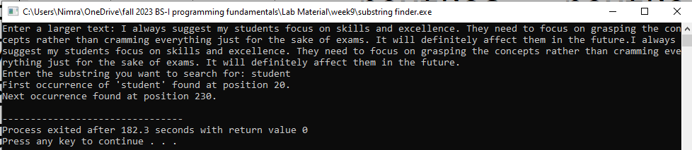

- String, Loop and Conditional - Password Validation
You are tasked with creating a user account management system for a secure application. To ensure user account security, you need to implement a password validation system. Write a C++ program that performs the following tasks:
Ask the user to create a new account by entering a username and password.
Implement password validation with the following criteria:
  - Password should be at least 8 characters long.
  - It must contain at least one uppercase letter.
  - It must contain at least one lowercase letter.
  - It must contain at least one digit.
  - It must contain at least one special character (e.g., !, @, #, $, etc.).
If the entered password meets the criteria, display a message indicating that the account has been created successfully. Otherwise, provide feedback to the user on which criteria were not met.
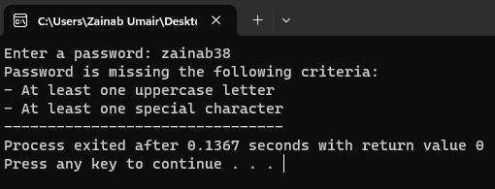
- Text Message Filtering
You are developing a text message filtering system for a messaging app. Your goal is to create a program that allows users to send messages while filtering out inappropriate words. You need to implement a system that checks each message for banned words and replaces them with asterisks (*) before sending. Write a C++ program that does the following:
- Ask the user to input a text message.
- Implement a filtering system that checks the message for banned words from a predefined list. You can start with words like "profanity," "spam," or any words you prefer.
- If any banned words are found in the message, replace them with asterisks (*) to censor them.
- Display the filtered message to the user.

